5 February 2020
[111-20]

Supporting document 3

Overview of the melon, berry and leafy vegetable industries in Australia

Proposal P1052 – Primary Production and Processing Requirements for High-risk Horticulture

Executive summary
This supporting document for Proposal P1052 – Primary Production and Processing Requirements for High Risk Horticulture (P1052) provides an overview of the Australian production of melons, berries and leafy vegetables. It includes how and where these commodities are grown and traded and information about production volumes, imports and exports. This information contributes to our understanding of the complexity and diversity of sectors that may be impacted by changes to regulatory food safety requirements.

In the 2017/18 financial year, Australia produced:
- 215,519 tonnes of melons (including watermelon and muskmelons) with a production value of $124.2 million
- 116,585 tonnes of berries (including strawberries, blueberries, blackberries and raspberries) with a production value of $911.4 million
- 205,156 tonnes of leafy vegetables (including head lettuce, leafy salad vegetables and leafy herbs) valued at $672.7 million.

Produce in these three sectors is grown in most or all states in Australia, enabling a year-round supply. Most produce is grown in open field systems, and is often picked and packed by hand. Product receives minimal processing (e.g. cooling, washing, drying, packaging) before distribution to wholesalers and retailers.

The majority of Australian production in these sectors is distributed as fresh product to domestic markets. Some product is further processed (e.g. fruit cut or frozen, herbs trimmed and gas-packaged). Relatively small proportions of total production are exported; predominantly melons and strawberries. Singapore, United Emirates and New Zealand are our biggest export markets. Minimal volumes of product from the three sectors are imported; mostly frozen strawberries and rubus berries.

Table of contents
Executive summary i
1 Introduction 2
1.1 Purpose 2
1.2 Scope 2
2 Melons 2
2.1 Description 2
2.2 Industry overview 3
2.3 Melon supply chain 3
2.3.1 On-farm activities 3
2.3.2 Packing shed activities 3
2.3.3 Distribution 3
2.4 Melon production 5
2.4.1 Production regions and availability 5
2.4.2 Exports and imports 5
3 Berries 6
3.1 Description 6
3.2 Industry overview 6
3.3 Berry supply chain 7
3.3.1 Strawberries 7
3.3.2 Blueberries 7
3.3.3 Rubus berries 8
3.4 Berry production 10
3.4.1 Production regions and availability 10
3.4.2 Exports and imports 11
4 Leafy vegetables 12
4.1 Description 12
4.2 Industry overview 12
4.3 Leafy vegetable supply chain 12
4.3.1 On-farm activities 12
4.3.2 Packing shed activities 13
4.3.3 Processor activities 15
4.3.4 Distribution 17
4.4 Leafy vegetable production 17
4.4.1 Production regions and availability 17
4.4.2 Exports and imports 18
References: 19

1 Introduction
Foodborne illness continues to be associated with fresh horticultural produce in Australia and internationally. Noting this, ministers responsible for food regulation in Australia agreed there is a need to reassess food safety measures in five high-risk horticultural sectors. These sectors are specified in annexes to the Codex Alimentarius Code of Hygienic Practice for Fresh Fruits and Vegetables (CoHP FFV). They are: ready-to-eat and minimally processed fruits and vegetables, fresh leafy green vegetables, melons, berries, and seed sprouts. Ministers have requested FSANZ to consider development of a primary production and processing (PPP) standard to manage food safety on-farm for these sectors.

When assessing the need for a standard, FSANZ must gain an understanding of the complexity and diversity of the sector/s involved. This includes how, where and when food is produced, processed and distributed, and what volumes are involved. This information contributes to analyses of the public health and safety risks and economic factors.

1.1 Purpose
The purpose of this paper is to provide an overview of domestic production for selected horticulture sectors (melons, berries and leafy vegetables) including:
- supply chain activities for the growth, harvest, packing, transport and distribution of product
- production statistics including product volumes, availability, growing regions and markets.

1.2 Scope
This paper will focus on three of the five identified high-risk sectors; namely melons, berries and leafy vegetables, since:
- ready-to-eat minimally processed fruits and vegetables are covered by current food safety requirements in Chapter 3 of the Australia New Zealand Food Standards Code (the Code)
- the production and processing of seed sprouts is covered by Standard 4.2.6 — Primary Production and Processing Standard for Seed Sprouts.

In the three sectors covered here, specific products are encompassed under each of the terms melon, berry and leafy vegetables.

2 Melons

2.1 Description
Melons are classified in Schedule 22 (Foods and classes of foods) of the Code as fruiting vegetables belonging to the botanical family Cucurbitaceae (cucurbits). They include watermelon, rockmelon, honeydew melon, galia melon, charentais melon, Korean melon, hami melon and piel de sapo.

The main species produced in Australia are watermelon, rockmelon and honeydew melon, with production of piel de sapo melon increasing in recent years. Varieties grown vary depending on market conditions and consumer preference. The term ‘muskmelons’ is used to describe rockmelon, honeydew melon and piel de sapo.

For this document, the term ‘melon’ will be used to collectively discuss watermelon, rockmelon, honeydew and piel de sapo melons.

2.2 Industry overview
Around 300 commercial melon growers produce about 200,000 tonnes (t) of melons each year in Australia. The estimated growing area is 6000–8000 hectares (Hort Innovation 2018). Australian melon production covers a wide range of geographical and climatic conditions, enabling year-round supply (Hort Innovation 2019a).

Watermelon is the most common melon grown, accounting for nearly 80% of production. Most melons produced in Australia are sold on the domestic market as either fresh whole or fresh cut fruit. Some whole fruit is also exported but virtually none is imported. Further details are provided below.

2.3 Melon supply chain
Melons are a ground vine, broad-acre crop that requires large areas of land to produce. All melon species in Australia are grown under field production systems involving similar practices. Figure 1 outlines on-farm and packing shed activities and inputs for melons. Key steps in the supply chain are described below.

2.3.1 On-farm activities
Melon seeds or seedlings are sourced from seed suppliers or commercial nurseries. Before planting, field preparation may include use of fumigants, herbicides, fertilisers or soil additives. Planting of seeds or seedlings can be done manually or mechanically, either directly into soil or through polythene mulch. Plants are watered through trickle, furrow or overhead irrigation. Fertilisers are applied through side dressings or irrigation. Vines are trained during growth onto beds so that developing fruit remains on mulch. The fruit may be placed on plastic cups or pads, or hand-turned by workers, to prevent development of ground spot blemishes.

Melons are manually harvested by cutting or twisting fruit off the vine. Picked melons are placed into harvest bins directly or by conveyor belts, then transported to packing sheds. Refrigerated vehicles are used for long distances.

2.3.2 Packing shed activities
On arrival at the packing shed, melons are cooled using forced-air coolers. Muskmelons are then either ‘dry dumped’ or ‘wet dumped’. Dry dumping involves placing fruit on conveyer belts that move through a water spray to remove soils, followed by sanitiser spray to reduce the level of surface microorganisms. Wet dumping involves immersing melons in large tanks filled with water containing sanitiser, then moving fruit along belts to be washed, scrubbed and further sanitised. They are then sprayed with or dipped in fungicide to prevent fruit rot. Following these treatments, the fruit is air-dried.

Melons are then sorted to remove undesirable fruit (e.g. overripe, misshapen) and to separate by colour and maturity. They are graded by size, packed into cartons or trays, palletised and stored in coolrooms. Some melons, particularly honeydew melons, may be ripened using ethylene gas before placing in cold storage.

Watermelons generally do not receive any treatment and are often packed in field.

2.3.3 Distribution
The distribution of melons can be complex, involving multiple businesses and business types. Melons are transported refrigerated to wholesale markets, distribution centres, processors, retailers or to the export market.
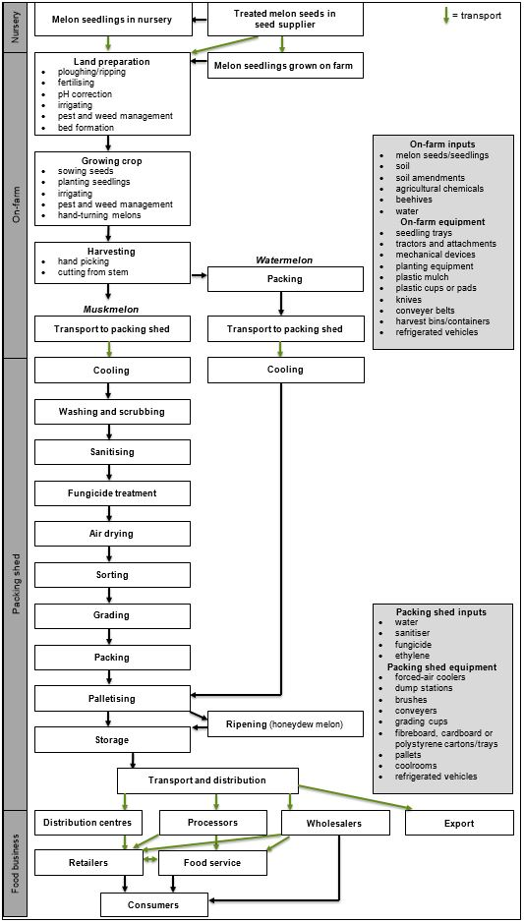
Figure 1 Generalised flow of activities and inputs for melon production in Australia
Based on information from DPI Qld (1997) and DPI NSW (2019).

2.4 Melon production
In the 2017/2018 financial year Australia produced 215,519 t of melons with a production value of $124.2m (Hort Innovation 2019a), as follows:
- Watermelon accounted for 79% of all production (170,039 t) with a value of $74.7 million (m).
- Muskmelon production accounted for 21% (45,480 t), valued at $49.5m.
- Within the muskmelon group, 85% of production was rockmelon (38,658 t), 14% was honeydew melon (6367 t) and 1% was piel de sapo (455 t).

2.4.1 Production regions and availability
Table 1 shows melon-growing regions across Australia and production volumes for the 2017/18 financial year. Production is concentrated in southern regions between January and July and moves north for July to December. Peak availability for each melon type is in the summer months (AMA 2016).

Queensland produces the most melons with production concentrated in Bowen, Bundaberg and Chinchilla (Hort Innovation 2019a). Significant volumes are also grown in Cowra and the Riverina in New South Wales (NSW), Darwin and Katherine in the Northern Territory and Perth, Carnarvon and Kununurra in Western Australia. Small volumes of melons are produced in Victoria and South Australia.

Table 1. Melon production across Australia in 2017/18 financial year
Berry | State | Jan | Feb | Mar | Apr | May | Jun | Jul | Aug | Sep | Oct | Nov | Dec | Volume produced (t)  2017-18 | % of total production 2017-18
Watermelons | Qld |  |  |  |  |  |  |  |  |  |  |  |  | 54,412 | 32
 | NSW |  |  |  |  |  |  |  |  |  |  |  |  | 44,210 | 26
 | NT |  |  |  |  |  |  |  |  |  |  |  |  | 42,510 | 25
 | WA |  |  |  |  |  |  |  |  |  |  |  |  | 23,805 | 14
 | Vic |  |  |  |  |  |  |  |  |  |  |  |  | 3401 | 2
 | SA |  |  |  |  |  |  |  |  |  |  |  |  | 1700 | 1
Muskmelons | Qld |  |  |  |  |  |  |  |  |  |  |  |  | 17,282 | 38
 | NSW |  |  |  |  |  |  |  |  |  |  |  |  | 14,554 | 32
 | WA |  |  |  |  |  |  |  |  |  |  |  |  | 6367 | 14
 | NT |  |  |  |  |  |  |  |  |  |  |  |  | 5003 | 11
 | Vic |  |  |  |  |  |  |  |  |  |  |  |  | 1364 | 3
 | SA |  |  |  |  |  |  |  |  |  |  |  |  | 910 | 2
Source: Hort Innovation (2019a). Shaded squares indicate melon availability.

Most melons are sent to the domestic market as whole fruit. In 2017/18, a total of 192,673 t (89% of production) was sold whole with a wholesale value of $114.4m (Hort Innovation 2019a), as follows:
- Watermelon accounted for 84% (161,672 t) with a wholesale value of $79.4m.
- Muskmelons accounted for 16% (31,046 t), valued at $35m.
About 1% (2575 t) of melon production is sent for further processing. About two thirds of this is watermelon (1684 t; 65%) and the rest is muskmelon (892 t; 35%) (Hort Innovation 2019a).

2.4.2 Exports and imports
Melon exports have steadily increased over the last five years, predominantly due to increased trade in watermelon. Export volumes and destinations for melons in 2017/2018 are listed in Table 2.

In 2017/2018, about 9% (20,271 t) of Australian melon production was exported at a value of $31.6m (Hort Innovation 2019a), as follows:
- Watermelon exports were 6728 t (around 4% of total watermelon production) valued at $8.4m.

- Muskmelon exports were 13,543 t (about 30% of total muskmelon production) valued at $23.6m.

United Arab Emirates and New Zealand were the main export markets by volume for all melons and Singapore was the largest market for muskmelons (Table 2).

Table 2. Exports of fresh melons from Australia in 2017/18 financial year
Product | Country | Volume (t) | % of total production
Watermelons | United Arab Emirates | 3330 | 49
 | New Zealand | 2744 | 41
 | Qatar | 345 | 5
 | Kuwait | 114 | 2
 | Papua New Guinea | 85 | 1
 | Other | 111 | 2
Muskmelons | Singapore | 5010 | 37
 | New Zealand | 3259 | 24
 | United Arab Emirates | 2928 | 22
 | Hong Kong | 857 | 6
 | Japan | 498 | 4
 | Other | 992 | 7
Source: Hort Innovation (2019a)

There are minimal imports of melon into Australia. In 2017/18, there were no watermelon imports. One tonne of muskmelons was imported into Queensland from New Zealand. The fresh import value was less than $0.1m (Hort Innovation 2019a).

3 Berries

3.1 Description
Schedule 22 of the Code describes berries as being derived from a variety of perennial plants and shrubs having fruit characterised by a high surface-to-weight ratio, with the seeds often eaten along with the fruit. The term ‘berries’ can include, but is not limited to, strawberries, blueberries, raspberries, blackberries, mulberries and currants. Raspberries, blackberries and their hybrid cultivars are members of the genus Rubus and are described together as rubus berries.

This document includes information on strawberries, blueberries and rubus berries.

3.2 Industry overview
Blueberries, blackberries, raspberries and strawberries are the four major berries grown in Australia and multiple varieties of each are produced. Boysenberry, loganberry, silvanberry and youngberry are rubus hybrid cultivars also grown, but in minimal quantities.

In 2014/15, there were approximately 260 strawberry growers and 120 raspberry and blackberry growers (Hort Innovation 2017a, 2017b). There were approximately 300 blueberry growers in 2017 (ABGA 2019a). Berries are grown in most Australian states, which enables year-round production (Hort Innovation 2019a). Strawberry production accounts for 80% of total production.

The majority of Australian berry production enters the domestic market as fresh ready-to-eat product. Some ‘pick your own’ enterprises allow customers to harvest their own berries for purchase. A small proportion of production is exported as fresh or frozen berries. There is minimal import of berries. Further details are provided below.

3.3 Berry supply chain
The main activities and inputs involved in berry production and supply are shown in Figure 2. The overall production of the different berry types is similar but there are a few differences, as described below.

3.3.1 Strawberries
In Australia most strawberries are grown on the ground in open fields. A small proportion is grown in glasshouses or hydroponically (Strawberries Australia 2013).

3.3.1.1 On-farm activities
Strawberries are grown from runners predominantly sourced from Victoria and Queensland. Commercial nurseries propagate runners under certification schemes. Field preparation includes ploughing soil into raised beds, which are covered with plastic (polythene) sheeting. Fumigants, herbicide, compost and other soil additives may be used. Runners are manually or mechanically planted into the beds then covered with protective polythene tunnels (cloches).

Water is supplied by trickle or sprinkler irrigation. Strawberries are harvested manually into trays that are taken to on-farm packing sheds. Refrigerated vehicles are used for long distances.

3.3.1.2 Packing shed activities
In the packing shed, harvested strawberries are quickly cooled by forced-air cooling systems. They are hand packed into punnets, stacked into cartons and stored in coolrooms before distribution. Fruit that is second or third grade may be packaged and frozen. Strawberries are sometimes sold directly to consumers from farm packing sheds (farm gate sales).

3.3.1.3 Distribution
The majority of strawberries are sold domestically. Fresh product is transported under refrigeration to retail distribution centres and wholesalers for supply to food service and direct to consumers. Second and third grade fruit may be sent for further processing.

3.3.2 Blueberries
In Australia, blueberries are mostly grown in open fields (orchards). Few growers use hydroponic production. The general flow of activities involved in blueberry production and processing is included in Figure 2.

3.3.2.1 On-farm activities
Blueberry plants are propagated from hardwood cuttings of disease-free mother plants and grown in open fields. Plants may be grown low to the ground (lowbush varieties) or up to three metres tall (highbush varieties). Field preparation may include the use of fertilisers, compost or other soil additives.

Plants are hand-planted into soil with compost or mulch applied. Netting may also be used to protect plants from birds and other pests. Water is applied to plants by trickle or micro-jet irrigation. Fertilisers can be applied directly to the base of plants, alongside them or through irrigation systems.

The fruit is generally harvested by hand and transported to on-farm packing sheds. Refrigerated vehicles are used for long distances.

3.3.2.2 Packing shed activities
Following harvest, blueberries are cooled using forced-air coolers. They are hand-sorted and hand-packed into retail punnets. Few operations have adopted machine packing. Punnets are packed into cardboard cartons and stored in coolrooms for distribution.

3.3.2.3 Distribution
Most blueberries are sold domestically. Fruit is transported under refrigeration to retail distribution centres, and to wholesalers who supply food service outlets and directly to consumers. Blueberries are also exported overseas. Some fruit is also sold on to food manufacturers/processors.

3.3.3 Rubus berries
In Australia, rubus berries are mostly grown in largescale, open field plantations. Rubus plants are tall erect shrubs with woody stems (canes) and grow best in colder climates. Production activities for rubus berries are based primarily on raspberry and blackberry production and included in Figure 2.

3.3.3.1 On-farm activities
Rubus plants are sourced through the Rubus Multiplication Scheme managed by Raspberries and Blackberries Australia. Growers may also propagate their own plants from established stock.

Following site preparation, rubus plants are hand planted. Rubus plants are positioned on trellises with wire or twine used to train plants to grow along them. Weed control coverings used include polyethylene sheeting and polythene or natural mulch. Raspberry plants are not usually grown through polythene sheeting.

Trickle or micro-jet irrigation systems are used and fertiliser may also be applied. The entire plantation may be covered with netting to protect it from birds. Shade clothes are often also erected for sun protection.

Most rubus berry operations hand-pick and field-grade ripe berries, which are packed directly into retail punnets. Large operations may use mechanical harvesters. Produce is taken to packing sheds. Refrigerated vehicles are used for long distances.

3.3.3.2 Packing shed activities
Following harvest, rubus berries are cooled using forced-air coolers. Punnets are packed into cardboard cartons and stored in coolrooms before distribution. Berries may also be frozen before distribution.

3.3.3.2 Distribution
Rubus berries are distributed in refrigerated vehicles. Hand-picked berries are distributed to
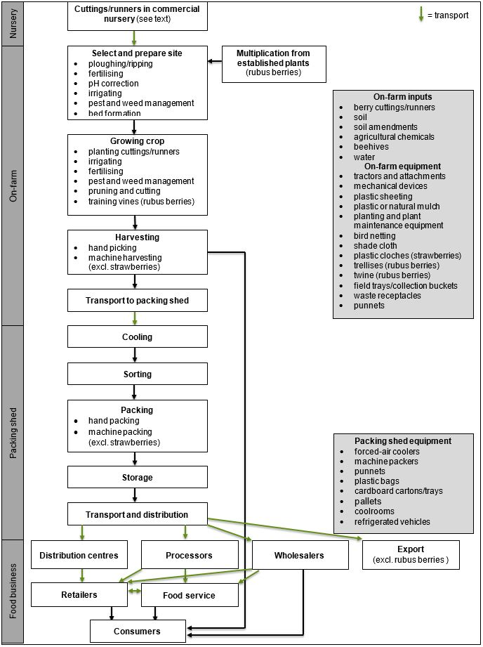
Figure 2 Generalised flow of activities and inputs for berry production in Australia
Diagram based on information from (DJPR Vic 2013a, 2013c), (DPIRD WA 2016a, 2016b, 2016c) and (ABGA 2019b).
the fresh market. Most are taken to retail distribution centres, and to wholesalers who supply food service outlets and directly to consumers. Mechanically harvested berries are often sent for further processing.

3.4 Berry production
Overall berry production for the 2017/2018 financial year was 116,585 t with a production value of $911.4m (Hort Innovation 2019a), as follows:
- Strawberries accounted for 80% (93,545 t) of all berry production, with a value of $445m.
- Blueberries and rubus berries accounted for around 5% each (6850 t worth $309m and 6189 t worth $157.3m respectively).
- Of the rubus berries, raspberries accounted for 85% (5261 t), followed by blackberries at 14% (867 t).

3.4.1 Production regions and availability
Berries are produced in most Australian states, enabling year-round production and availability. Table 3 shows growing regions and production volumes for strawberries, blueberries and rubus berries in 2017/18.

Strawberry production occurs in most Australian states with the majority in Beerwah (Queensland) and the Yarra Valley (Victoria). Western Australia and South Australia together produce 17% of supply, while Tasmania and NSW are smaller producers (Hort Innovation 2019).

For blueberries, Coffs Harbour (NSW) is the major producing region, with significant production also in Tumbarumba (NSW). Smaller volumes are grown in Tasmania, Queensland and Victoria.

Rubus berries are produced in most states but Tasmania, Victoria and NSW produce the majority. Raspberries are available all year round, with peak availability occurring from October to April. Blackberries are available from November to February, with peak availability occurring from December to January. Other rubus berries are available from November to February (Hort Innovation 2019a).

Table 3. Berry production across Australia 2017/18 financial year
Berry | State | Jan | Feb | Mar | Apr | May | Jun | Jul | Aug | Sept | Oct | Nov | Dec | Volume produced (t) | % of total production
Strawberries | Qld |  |  |  |  |  |  |  |  |  |  |  |  | 39,289 | 42
 | Vic |  |  |  |  |  |  |  |  |  |  |  |  | 33,209 | 36
 | WA |  |  |  |  |  |  |  |  |  |  |  |  | 9822 | 10
 | SA |  |  |  |  |  |  |  |  |  |  |  |  | 6548 | 7
 | Tas |  |  |  |  |  |  |  |  |  |  |  |  | 3742 | 4
 | NSW |  |  |  |  |  |  |  |  |  |  |  |  | 935 | 1
Blueberries | NSW |  |  |  |  |  |  |  |  |  |  |  |  | 14,659 | 87
 | Tas |  |  |  |  |  |  |  |  |  |  |  |  | 1095 | 6
 | Qld |  |  |  |  |  |  |  |  |  |  |  |  | 674 | 4
 | Vic |  |  |  |  |  |  |  |  |  |  |  |  | 337 | 2
 | SA |  |  |  |  |  |  |  |  |  |  |  |  | 84 | <1
Rubus berries | Tas |  |  |  |  |  |  |  |  |  |  |  |  | 1777 | 29
 | Vic |  |  |  |  |  |  |  |  |  |  |  |  | 1593 | 26
 | NSW |  |  |  |  |  |  |  |  |  |  |  |  | 1409 | 23
 | Qld |  |  |  |  |  |  |  |  |  |  |  |  | 980 | 16
 | WA |  |  |  |  |  |  |  |  |  |  |  |  | 306 | 5
 | SA |  |  |  |  |  |  |  |  |  |  |  |  | 123 | 2
Source: Hort Innovation (2019a). Shaded squares indicate berry availability.

3.4.2 Exports and imports
Australia exports more berries than it imports, with strawberries the main berry export and increasing over recent years. Export volumes and destinations for strawberries, blueberries and rubus berries for 2017/18 are listed in Table 4.

In 2017/18, a total of 4529 t of fresh berries were exported from Australia with a market value of $34.2m (Hort Innovation 2019a), as follows:
- Fresh strawberries accounted for 95% (4304 t), with an export value of $29.7m.
- Blueberry exports accounted for 4.8% (221 t), with a value of $4.4m.
- Fresh rubus berries exports totalled 4 t, with a value of <0.1m.

In addition to fresh berries, 239 t of processed strawberries (98% of which were frozen product) and 79 t of frozen rubus berries were exported in 2017/18 (Hort Innovation 2019a).

Table 4. Exports of fresh berries from Australia 2017/2018 financial year
Product | Country | Volume (t) | % of total volume
Strawberries | Unites Arab Emirates | 797 | 19
 | New Zealand | 770 | 18
 | Singapore | 734 | 17
 | Thailand | 617 | 14
 | Hong Kong | 491 | 11
 | Other | 895 | 21
Blueberries | Hong Kong | 112 | 50
 | Singapore | 59 | 27
 | Thailand | 26 | 12
 | United Arab Emirates | 8 | 4
 | India | 4 | 2
 | Other | 12 | 5
Rubus berries | India | 2 | 54
 | Fiji | 1 | 20
 | Indonesia | <0.5 | -
 | Papua New Guinea | <0.5 | -
 | New Caledonia | <0.5 | -
 | Other | 1 | 26
Source: Hort Innovation (2019a).

Berry imports into Australia are relatively small. In 2017/2018, fresh berry imports were 1235 t with an import value of $29.5m (Hort Innovation 2019a), as follows:
- Most imports (99.8%) were fresh blueberries from New Zealand, plus minimal amounts from Iran (1%), United Kingdom and other countries.
- Less than 1 t of fresh strawberries was imported from South Korea, with a value below $0.1m.
- There were no imports of fresh rubus berries.

In addition to fresh berries, 4784 t of frozen strawberries, 377 t of preserved strawberries and 9357 t of frozen rubus berries were imported in 2017/18 (Hort Innovation 2019a).

4 Leafy vegetables

4.1 Description
Fresh leafy vegetables and herbs include all vegetables and herbs of a leafy nature and of which the leaf (and core) is intended to be consumed raw (FAO/WHO 2008a, 2008b). Examples are lettuce (all varieties), spinach, cabbages, chicory, leafy herbs (coriander, basil, parsley etc.) and watercress. Schedule 22 of the Code classifies leafy vegetables (including brassica leafy vegetables) as a large variety of edible plants with a high surface-to-weight ratio.
For this paper, ‘leafy vegetables’ covers all varieties of head lettuce, leafy salad vegetables (including loose leaf lettuce), and leafy herbs – all intended for fresh consumption. All other leafy vegetables including cabbages and other leafy brassicas, leafy Asian vegetables and spinach (apart from baby spinach), intended to be consumed cooked, are excluded.

4.2 Industry overview
Australia produces a diverse range of leafy vegetables, supported by consumer demand for choice and convenience. Dense head lettuces include cos, iceberg and oak, and a variety of leafy salad vegetables including baby spinach and rocket. Leafy herbs include basil, chives, coriander, mint and parsley amongst others.

Leafy vegetables are produced in all Australian states, enabling year-round production and availability. Head lettuce is produced in the highest total volume. Leafy salad vegetables account for the highest total value.

Most produce is distributed domestically. Washed, bagged, and ready-to-eat products are popular (Woodward 2018). In 2017/18, 70% of Australian households purchased head lettuce, 55% purchased leafy salad vegetables and 38% purchased leafy herbs (Hort Innovation 2019b).

A relatively small volume of head lettuce and leafy salad vegetables are exported; minimal volumes are imported. There is no import or export of leafy herbs.

4.3 Leafy vegetable supply chain
In Australia, fresh leafy vegetables are primarily grown in open fields. Some growers use hydroponic or greenhouse production systems. Production covers wide geographic and climatic conditions. Primary production and processing methods vary between head lettuce, leafy salad vegetables and leafy herbs, as described below.

4.3.1 On-farm activities
The on-farm activities and inputs for leafy vegetables are summarised in Figure 3.

Leafy vegetables are grown from seeds or seedlings purchased from seed suppliers and commercial nurseries. Some growers raise their own seedlings to transplant. Field preparation may include ploughing, forming soil beds, applying fertiliser and correcting soil pH. Seeds are sown directly into soil by hand or using a seed machine. Seedlings are planted by hand or with transplanting machines.

Side dressings of fertiliser, often heat-treated manure, are applied during growth. Water is supplied through drip, furrow or overhead irrigation. Crops are monitored and controlled for pests and weeds.

Leafy vegetables are generally harvested by hand, although mechanical harvesters are available for lettuces. Harvested products are collected in containers or crates. Some head lettuces are field trimmed, cored, packed into waxed cartons and palletised to be sent directly to market as a ready-to-wash product. Containers and crates are palletised and transported to packing sheds; refrigerated vehicles are used for long distances.

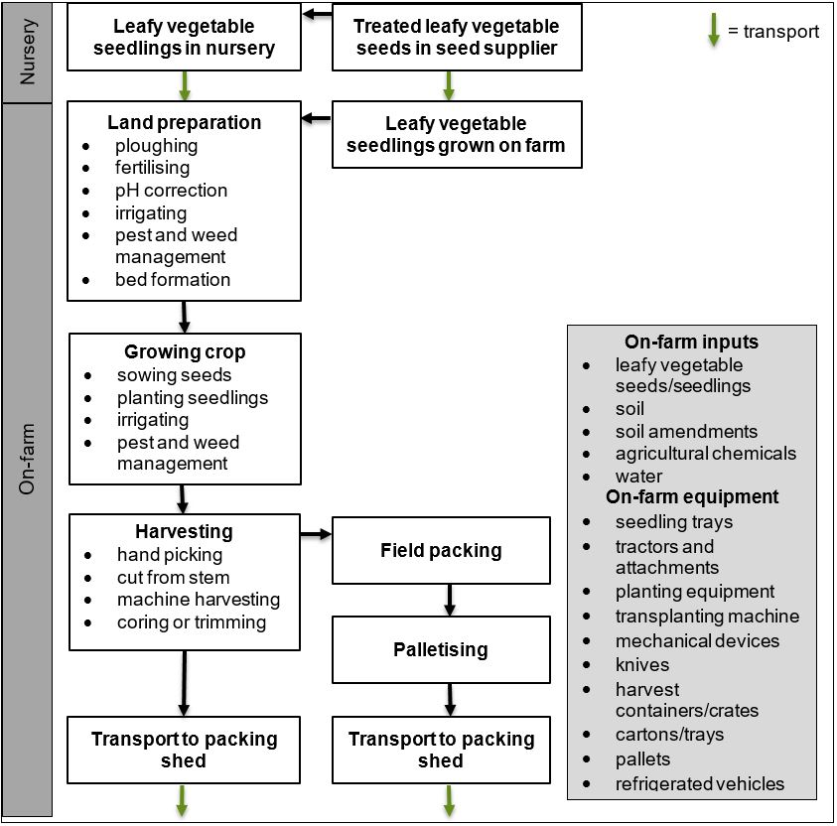
Figure 3. Generalised on-farm activities and inputs for leafy vegetable production in Australia
Diagram based on information in IFPA, PMA, UFFVA, WGA (2006) and DJPR Vic (2013b).

4.3.2 Packing shed activities
The activities and inputs at packing sheds for head lettuce and leafy salad vegetables (summarised in Figure 4) differ slightly from leafy herbs (Figure 5).

Harvested head lettuce and leafy salad vegetables in crates, containers, or cartons are immediately cooled using forced air, vacuum or hydrovac cooling. They are then washed, sorted, trimmed and sanitised. This is followed by drying with air-drying systems or commercial spinners. Product is packed into plastic bags or sleeves, or bulk-packed into cartons or crates. Packed products are then palletised, shrink wrapped and stored in coolrooms before distribution.

Leafy herbs are also immediately cooled upon receipt. They are not commonly treated with sanitisers but are regularly sprayed with or dipped in water to prevent moisture loss. Leafy herbs are bunched, packed into plastic bags, punnets or plastic film, and then placed into waxed cartons. Unpackaged herbs may also be bulk-packed into styrofoam boxes or waxed cartons.

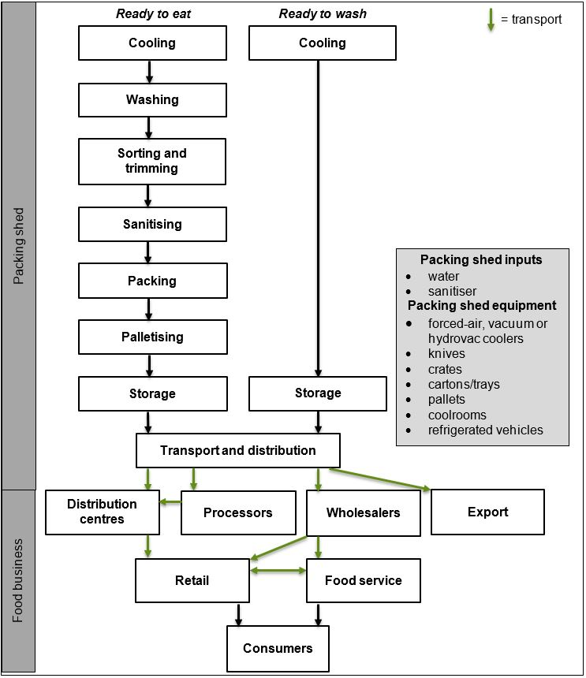
Figure 4. Generalised packing shed activities and inputs for head lettuce and leafy salad vegetable production in Australia
Diagram based on information in DJPR Vic (2013b) and AFPA (2019).

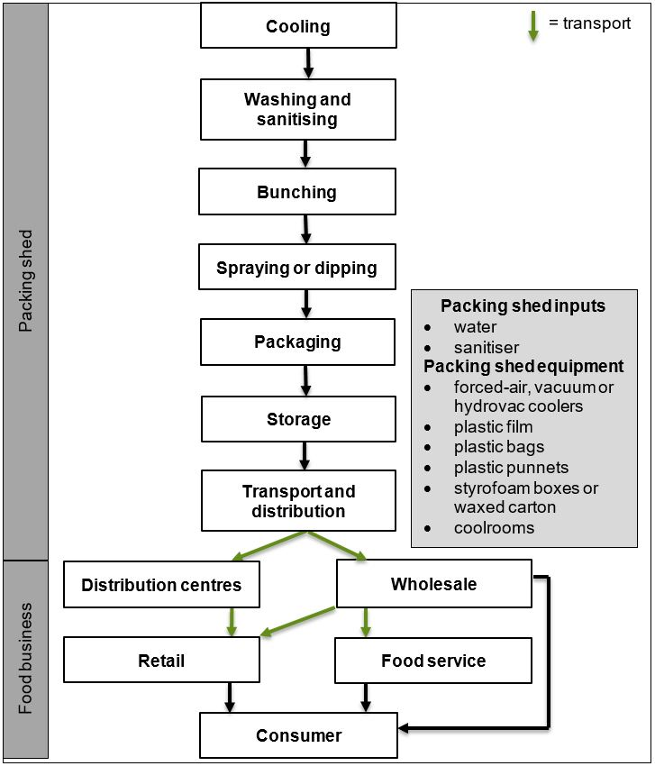
Figure 5. Generalised packing shed activities and inputs for leafy herb production in Australia
Diagram based on information in RIRDC (1997).

4.3.3 Processor activities
Some leafy vegetables (washed or unwashed) are sent for further processing. Processor activities are summarised in Figure 6. Most activities in processing factories use mechanical or robotic equipment. Products are washed, trimmed and sanitised. They are then dried in air-drying systems or spinners and packed into plastic bags. For some products (e.g. ready-to-eat leafy salads) the plastic bag is gas flushed (modified atmosphere packaging) before sealing. Packed products are palletised and stored in coolrooms before distribution.

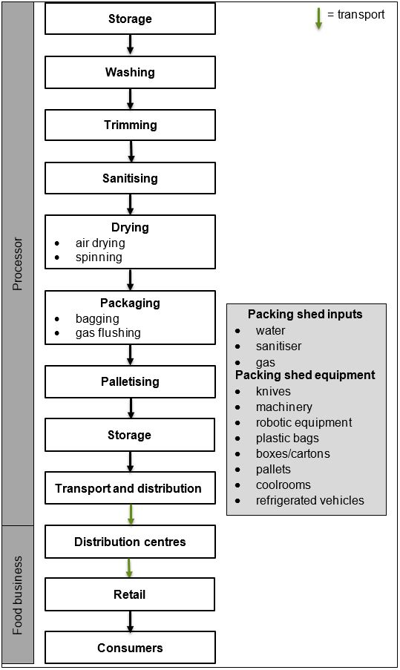
Figure 6. Generalised processor activities and inputs for leafy vegetable production in Australia
Diagram based on information from DJPR Vic (2013b) and AFPA (2019).

4.3.4 Distribution
From the packing shed, ready-to-wash or ready-to-eat leafy vegetables are transported under refrigeration to distribution centres, wholesale markets, or processors. Processors send processed products to distribution centres. The distribution centres dispatch products to retail stores, and wholesale markets to food service outlets. Consumers can purchase products directly from wholesale markets or retail outlets.

4.4 Leafy vegetable production
In the 2017/18 financial year, Australia produced a total of 205,156 t of leafy vegetables valued at $672.7m (Hort Innovation 2019b), as follows:
- Fresh head lettuce production was 138,485 t with a value of $147.1m. This included iceberg lettuce (75%), cos lettuce (20%) and oak lettuce (4%).
- Fresh leafy salad vegetables production was 56,297 t with a value of $348.7m.
- Fresh leafy herbs production was 10,374 t, worth $176.9m. This included coriander (28%), parsley (26%), basil (17%), mint (9%) and chives (5%).

4.4.1 Production regions and availability
Leafy vegetables are produced in all Australian states, enabling year-round production and availability (Hort Innovation 2019b). Crops are primarily grown close to state capitals and other major population centres.

Head lettuce is grown in all Australian states, but most is produced in Victoria and Queensland. Major production areas include Lockyer Valley and Darling Downs in Queensland, the Gippsland region in Victoria and Sydney Basin in NSW (Hort Innovation 2019b).

Table 5. Leafy vegetable production across Australia 2017/18
Product | State | Jan | Feb | Mar | Apr | May | Jun | Jul | Aug | Sep | Oct | Nov | Dec | Volume produced (t) | % of total production
Head lettuce | Vic |  |  |  |  |  |  |  |  |  |  |  |  | 54,588 | 39
 | Qld |  |  |  |  |  |  |  |  |  |  |  |  | 52,562 | 38
 | WA |  |  |  |  |  |  |  |  |  |  |  |  | 14,949 | 11
 | NSW |  |  |  |  |  |  |  |  |  |  |  |  | 9366 | 7
 | SA |  |  |  |  |  |  |  |  |  |  |  |  | 6351 | 5
 | Tas |  |  |  |  |  |  |  |  |  |  |  |  | 659 | <1
Leafy salad vegetables | Vic |  |  |  |  |  |  |  |  |  |  |  |  | 25,159 | 45
 | Qld |  |  |  |  |  |  |  |  |  |  |  |  | 15,575 | 28
 | Tas |  |  |  |  |  |  |  |  |  |  |  |  | 5391 | 10
 | NSW |  |  |  |  |  |  |  |  |  |  |  |  | 4193 | 7
 | SA |  |  |  |  |  |  |  |  |  |  |  |  | 4193 | 7
 | WA |  |  |  |  |  |  |  |  |  |  |  |  | 1785 | 3
Leafy herbs | Qld |  |  |  |  |  |  |  |  |  |  |  |  | 4772 | 46
 | Vic |  |  |  |  |  |  |  |  |  |  |  |  | 3112 | 30
 | NSW |  |  |  |  |  |  |  |  |  |  |  |  | 1971 | 19
 | SA |  |  |  |  |  |  |  |  |  |  |  |  | 218 | 2
 | WA |  |  |  |  |  |  |  |  |  |  |  |  | 197 | 2
 | Tas |  |  |  |  |  |  |  |  |  |  |  |  | 104 | 1
Source: Hort Innovation (2019b). Shaded squares indicate leafy vegetable availability.

Leafy salad vegetables are also grown in all Australian states, with Victoria the largest producer. Major production areas include Bacchus March and the Gippsland region in Victoria, and Gatton in Queensland.

Leafy herbs are grown in all Australian states, mostly near the capitals. Queensland is the largest producer. Major production areas include Cairns and Rockhampton in Queensland, north east Tasmania, and the Sydney Basin and northern region of NSW.

4.4.2 Exports and imports
Export volumes and destinations for fresh leafy vegetables in 2017/18 are listed in Table 6. Fresh exports included (Hort Innovation 2019b):
- 432 t of head lettuce with a fresh export value of $1.7m. Western Australia exported just over half (228 t, 53%).
- Fresh leafy salad vegetables exports totalled 1358 t, with a value of $9.4m; almost two thirds were exported from Victoria (857 t, 63%).
- There were no exports of fresh leafy herbs in Australia for 2017/18.

Table 6. Exports of fresh head lettuce and leafy salad vegetables
from Australia 2017/18 financial year
Product | Country | Volume (t) | % of total production
Fresh head lettuce | Singapore | 323 | 75
 | Indonesia | 28 | 7
 | Japan | 18 | 4
 | Fiji | 14 | 3
 | Hong Kong | 13 | 3
 | Other | 37 | 8
Fresh leafy salad vegetables | Singapore | 614 | 45
 | Hong Kong | 380 | 28
 | Malaysia | 73 | 5
 | Indonesia | 66 | 5
 | Thailand | 56 | 4
 | Other | 171 | 13
Source: Hort Innovation (2019b).

There is generally no annual import of head lettuce or leafy salad vegetables and there were no imports of these products in 2017/18 (Hort Innovation 2019b). However, in 2016/17 about 1 t of head lettuce was imported, half of which was from China. Australia also imported 4 t of fresh leafy salad vegetables, all from New Zealand. There were no imports of fresh leafy herbs in Australia for the 2017/18 year

References:
ABGA (2019a) Blueberry code of conduct. Australian Blueberry Growers' Association, Lindendale NSW. https://abga.com.au/wp-content/uploads/2018/07/BlueberryCodeOfConduct-Final.pdf. Accessed 21 August 2019
ABGA (2019b) Growing blueberries. Australian Blueberry Growers' Association, Lindendale NSW. https://www.google.com/search?q=abga+growing+blueberries&sourceid=ie7&rls=com.microsoft:en-AU:IE-Address&ie=&oe=#spf=1574060920885. Accessed 12 November 2019
AFPA (2019) The role of packaging for Australian fresh produce. Australian Fresh Produce Alliance, Melbourne. http://freshproduce.org.au/__static/be3a3d70b2196781fe0d847f73cbf677/afpa-report-2019-digital-book_(4).pdf?dl=1. Accessed 15 November 2019
AMA (2016) Australian melon industry strategic investment plan 2016-2021. Australian Melon Association Inc., Brisbane. https://www.melonsaustralia.org.au/wp-content/uploads/2018/12/Australian-Melon-Industry-Strategic-Plan_final-draft.pdf. Accessed 8 August 2019
DJPR Vic (2013a) Bramble fruits. Department of Jobs, Precincts and Regions Victoria, Melbourne. http://agriculture.vic.gov.au/agriculture/horticulture/fruit-and-nuts/berries/bramble-fruits. Accessed 13 November 2019
DJPR Vic (2013b) Lettuce. Department of Jobs, Precincts and Regions Victoria, Melbourne. http://agriculture.vic.gov.au/agriculture/horticulture/vegetables/vegetables-a-z/lettuce. Accessed 15 November 2019
DJPR Vic (2013c) Raspberries and blackberries: Establishment and management. Department of Jobs, Precincts and Regions Victoria, Melbourne. http://agriculture.vic.gov.au/agriculture/horticulture/fruit-and-nuts/berries/rasberries-and-blackberries-establishment-and-management. Accessed 13 November 2019
DPI NSW (2019) Melon food safety: a best practice guide for rockmelons and specialty melons. Department of Primary Industries New South Wales, Sydney.
DPI Qld (1997) Rockmelon and honeydew information kit. Department of Primary Industries Queensland, Brisbane. http://era.daf.qld.gov.au/id/eprint/1650/. Accessed 11 November 2019
DPIRD WA (2016a) Growing blueberries in Western Australia. Department of Primary Industries and Regional Development Western Australia, Perth. https://www.agric.wa.gov.au/minor-fruits/growing-blueberries-western-australia. Accessed 12 November 2019
DPIRD WA (2016b) Preparing to grow strawberries. Department of Primary Industries and Regional Development Western Australia, Perth. https://www.agric.wa.gov.au/strawberries/preparing-grow-strawberries. Accessed 12 November 2019
DPIRD WA (2016c) Strawberries - growing the crop. Department of Primary Industries and Regional Development Western Australia, Perth. https://www.agric.wa.gov.au/strawberries/strawberries-growing-crop. Accessed 12 November 2019
FAO/WHO (2008a) Microbiological hazards in fresh fruits and vegetables: Meeting report. Microbiological risk assessment series (pre-publication version). www.fao.org/fileadmin/templates/agns/pdf/jemra/FFV_2007_Final.pdf. Accessed 9 May 2019
FAO/WHO (2008b) Microbiological hazards in fresh leafy vegetables and herbs: Meeting report. Microbiological risk assessment series 14. www.fao.org/3/a-i0452e.pdf. Accessed 9 May 2019
Hort Innovation (2017a) Raspberry and blackberry strategic investment plan. Horticulture Innovation Australia, Sydney. https://www.horticulture.com.au/globalassets/hort-innovation/levy-fund-financial-and-management-documents/sip-pdfs-new/hortinnovation-sip-raspberry-blackberry-2017-2021.pdf. Accessed 21 August 2019
Hort Innovation (2017b) Strawberry strategic investment plan 2017-2021. Horticulture Innovation Australia, Sydney. https://www.horticulture.com.au/globalassets/hort-innovation/levy-fund-financial-and-management-documents/sip-pdfs-new/hortinnovation-sip-strawberry-2017-2021.pdf. Accessed 21 August 2019
Hort Innovation (2018) Melon strategic investment plan 2018-2021. Horticulture Innovation Australia, Sydney. https://www.horticulture.com.au/globalassets/hort-innovation/levy-fund-financial-and-management-documents/sip-pdfs-new/hortinnovation-sip-melon-2018-2021.pdf. Accessed 8 August 2019
Hort Innovation (2019a) Australian horticulture statistics handbook: Fruit 2017/18. Horticulture Innovation Australia, Sydney. https://www.horticulture.com.au/globalassets/hort-innovation/resource-assets/ah15001-australian-horticulture-statistics-handbook-fruit-.pdf. Accessed 8 August 2019
Hort Innovation (2019b) Australian horticulture statistics handbook: Vegetables 2017/18. Horticulture Innovation Australia, Sydney. www.horticulture.com.au/globalassets/hort-innovation/resource-assets/ah15001-australian-horticulture-statistics-handbook-vegetables.pdf. Accessed 8 August 2019
IFPA, PMA. UFFVA, WGA (2006) Commodity specific food safety guidelines for the lettuce and leafy greens supply chain. International Fresh-cut Produce Association, Produce Marketing Australia, United Fresh Fruit and Vegetable Association, Western Growers Association. https://www.fda.gov/media/77279/download. Accessed 15 November 2019
RIRDC (1997) Postharvest handling and packaging of fresh herbs. Rural Industries Research & Development Corporation, Barton ACT. https://www.researchgate.net/profile/Bruce_Tomkins/publication/242549288_Postharvest_Handling_and_Packaging_of_Fresh_Herbs/links/5784288108ae37d3af6c1673/Postharvest-Handling-and-Packaging-of-Fresh-Herbs.pdf. Accessed 15 November 2019
Strawberries Australia (2013) About strawberries. http://www.strawberriesaustralia.com.au/6836950/strawberries-australia-about-strawberries.htm. Accessed 30 May 2019
Woodward J (2018) Leafy green horticulture survey. SA Health, Adelaide. https://www.sahealth.sa.gov.au/wps/wcm/connect/public+content/sa+health+internet/resources/food+safety+survey+report+-+leafy+greens+horticulture+survey+2017-2018. Accessed 4 September 2019

Consistent with FAO/WHO (2008b), the word ‘green’ is excluded since “some varieties may be colours other than green, and this term may be misleading and result in the exclusion of some varieties”.

